Figure 5: Synthetic Difference-in-Difference Event-Study Plots, ACS 2016-2022
Figure 5a. In-migration, full county sample, with covariates and excluding 2020
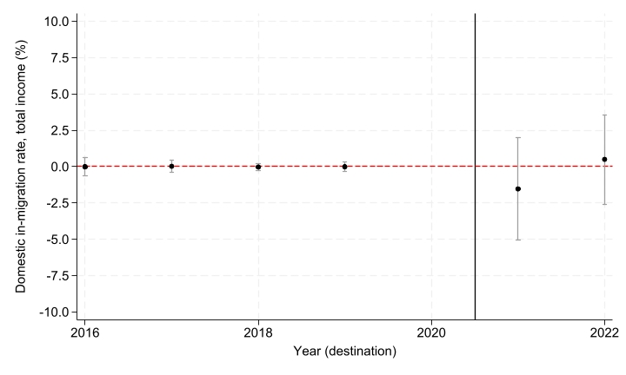
Figure 5b. In-migration, urban covid-matching counties, with covariates and excluding 2020
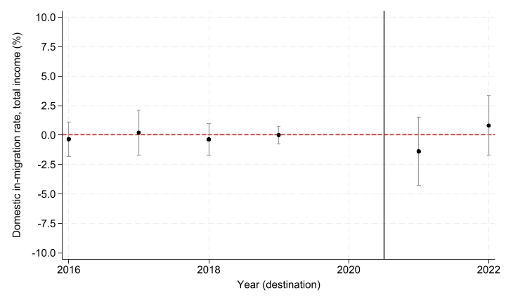

Figure 5c. Out-migration, full county sample, with covariates and excluding 2020
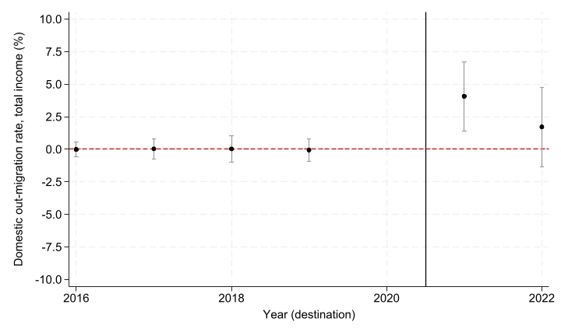
Figure 5d. Out-migration, urban covid-matching counties, with covariates and excluding 2020
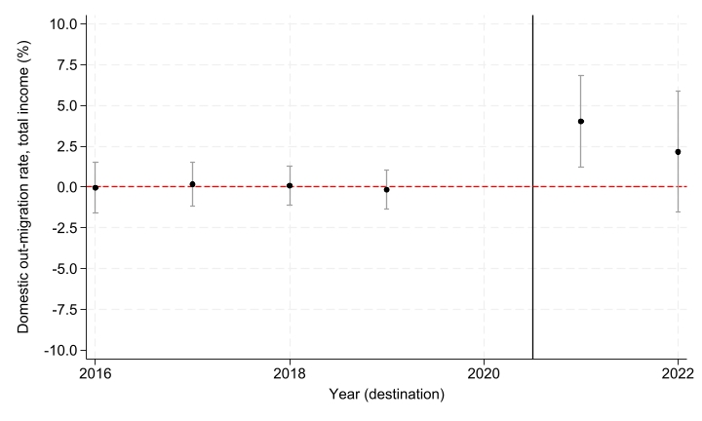

Figure 5e. Net-migration, full county sample, with covariates and excluding 2020
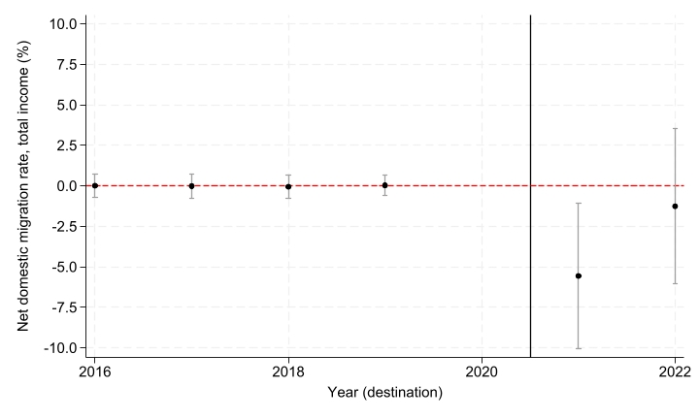

Figure 5f. Net-migration, urban covid-matching counties, with covariates and excluding 2020
